Slide 1
Introduction
Definition: A sequence where each term is the sum of the previous two numbers.

Formula:
F(n)=F(n-1)+F(n-2)
f(n)=f(n-1)+f(n-2)
F=φn-(1-φ)n/51/2
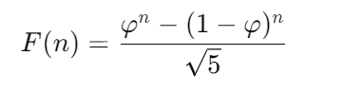
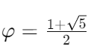
Sequence: Begins 0,1,1,2,3,5,8……..
Origin : fibonacci was introduced by Leonardo Fibonacci in 1202 in Liber Abaci.
Applications: Fibonacci is often used in science, engineering, nature, computer science and construction.
Golden Ratio: two quantities are in the golden ratio if their ratio is the same as the ratio of their sum to the larger of the two quantities.
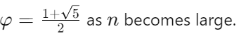
Properties: Fibonacci numbers have unique properties in divisibility, combinatorics, and growth patterns.

Slide 2
Recursive Method
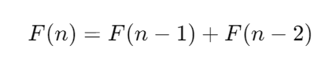
Structure: This formula defines each Fibonacci number as the sum of the two preceding numbers, starting with the initial values.

Uses of first Equation: The recursive definition is simple and reflects the natural "growth" pattern observed in many natural phenomena, making it useful in recursive algorithms and introductory programming exercises.
Drawback: The Quadratic Time Complexity: The time complexity of an algorithm describes how its runtime grows with the size of the input. In the case of our recursive Fibonacci function, the time complexity is quadratic O(n^2)).

Slide 3
Binet’s Formula
Advantage over recursive method: Unlike the recursive formula, Binet's formula calculates F(n) directly, without needing prior terms. This makes it highly efficient, especially for large F(n).
Golden Ratio: The formula involves the golden ratio φ≈1.618, which relates closely to the Fibonacci sequence. The sequence's growth rate approaches φ as n increases.
Approximation: The term (1−φ)^n quickly approaches zero for larger n, so 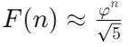 \​ becomes a good approximation for large numbers.

Applications: It is useful when the value of n is large and you need to calculate the nth Fibonacci number quickly and accurately. be accurate for small values of n due to limitations of floating-point precision. values of n. for large values of n because of the overhead of multiple function calls.

Limits: Since Binet's formula relies on irrational numbers and square roots, it is more theoretical. In practice, for large nnn, floating-point precision limits its accuracy.

SLIDE 4:
Golden Ratio:
The golden ratio, also known as the golden number, golden proportion, or the divine proportion, is a ratio between two numbers that equals approximately 1.618. Usually written as the Greek letter phi, it is strongly associated with the Fibonacci sequence, a series of numbers wherein each number is added to the last.
ACTIVITY:
Golden ratio of face
lenght/width=1.6

Slide 5:
Uses of golden ratio:
Face symmetry:
Arts and Architecture: Leonardo da Vinci’s works, the Parthenon.
Nature and Biology:the spiral shapes of shells, and the branching of trees
Design: layout dimensions, logo designs, and font sizes

